PROFESSIONAL SCHOOL COUNSELING PROGRAM
DEPARTMENT OF HUMAN DEVELOPMENT & PSYCHOLOGICAL COUNSELING
Revised 8/15

Dear Fall 2015 Entering Cohort of Students,

As the Director of the Professional School Counseling Program (PSC), let me extend a warm welcome to you on behalf of the faculty and staff of the Department of Human Development and Psychological Counseling (HPC), the Reich College of Education (RCOE), the Graduate School (GS), and Appalachian State University (ASU)!

During your time here in the PSC program, you will learn more about who you are as a person and your ability to encourage and support others. As you work towards becoming a Professional School Counselor in the K-12 school setting, please take advantage of the many opportunities that are available to you, both on campus and off, that will help you develop your professional identity and competency as a counselor. We encourage you to become active in professional organizations such as the American Counseling Association, the American School Counseling Association, the North Carolina School Counseling Association, and the North Carolina Counseling Association.

This handbook is meant to serve as your blueprint for the PSC program and for some of our HPC departmental policies (see the HPC Student Handbook for full description). It will provide you with information about your program of study, advising, field placement procedures, and ways to be involved in the program and the field of counseling. Consult this manual and your advisor often to ensure smooth progression through the program. Also keep up to date with the program by:
- reviewing the PSC Program website, the Graduate School website, and the HPC website
- reviewing the PSC Program Orientation materials provided to you in Intro to PSC (5310)
- keeping up with email listserv messages (you will be automatically registered for this)

The PSC Program at ASU is committed to excellence in school counselor preparation. We welcome your feedback about your experience of the program. Good luck as you progress through this wonderful, often transformative experience.

Sincerely,

Elizabeth
Elizabeth Graves, Ph.D., LPCS, NCC, ACS
Director of the Professional School Counseling Program
Department of Human Development and Psychological Counseling
TABLE OF CONTENTS

Program Statements, Background & Faculty 1
Program of Study 4
Program Policies and Procedures 6
Academic Appeals Process 7
Professional Identity Development during PSC 11
Comprehensive Exams 12
Counselor Competency Scale 13
Employment & Endorsement Policies 14
Counselor Competency Scale 15
CACREP Standards (2009) 20
Program Checkpoints and Timeline 28

PROGRAM STATEMENTS, BACKGROUND & FACULTY

Program Description

The M.A. in Professional School Counseling (427*) is a sixty semester hour program. The master’s program is designed to meet the requirements for North Carolina K-12 School Counselor Licensure through the North Carolina Department of Public Instruction (NCDPI) and to follow guidelines and standards of the Council for the Accreditation of Education Programs (CAEP) and the Council for Accreditation of Counseling and Related Educational Programs (CACREP). Approval by these additional accrediting agencies allows graduates to be eligible in various other states for school counseling licensure. Our 60-hour program affords our graduates the opportunity to further develop their counseling skills and to graduate at the Specialist (S) level status for school counselor licensure in North Carolina.

Mission Statement

The master’s program in Professional School Counseling at Appalachian State University is designed to meet the requirements for the North Carolina K-12 School Counselor Licensure through the North Carolina Department of Public Instruction (NCDPI) and to carry out the functions identified in their school counselor job description. Additionally, this program meets standards of both the Council for the Accreditation of Education Programs (CAEP) and the Council for Accreditation of Counseling and Related Educational Programs (CACREP).
Utilizing experiential, contemplative/reflective, and traditional approaches, the Professional School Counseling program provides transformative classroom and field placement experiences which prepare graduates for distinguished service in the school counseling field. Graduates of our program employ their leadership, advocacy, collaboration, and positive systemic change skills to implement developmental, comprehensive, preventive, responsive school counseling programs. The goal of these programs is to address the needs of diverse student populations, thereby supporting the academic achievement, career development, and personal/social growth of all students. Equally, it is our goal to prepare school counselors who care deeply about children and who possess the skills necessary to impact students’ lives in positive ways within their schools, communities, and families. To this end, this program also requires a good deal of self-examination, self-awareness, and self-knowledge, for, without these, the higher ethical charge ‘to do no harm’ to populations of minor children is not possible.
Historical Background

This program is one of only a handful of programs in North Carolina that is nationally accredited by the Council for Accreditation of Counseling and Related Educational Programs (CACREP). Additionally, ours was the first program in North Carolina to be accredited (1970s) and still maintains a reputation for excellence in counselor preparation. Additionally, Appalachian State University historically has an outstanding reputation for preparing educators and has thus played a significant role in preparing graduate and undergraduate professional educators for work in the Northwestern and Western Piedmont regions of North Carolina. This responsibility includes the preparation of professional school counselors to meet employment needs within the western North Carolina region. Currently, the demand for licensed school counselors across the state and the Southeast region of the United States is greater than the capacity of counselor education programs in North Carolina and the region to meet the demand. Surveys indicate the likelihood that this need will continue to increase.

Accreditations

The Professional School Counseling program at Appalachian State University is accredited by the Council for Accreditation of Counseling and Related Educational Programs (CACREP) under the 2009 standards (http://www.cacrep.org/wp-content/uploads/2013/12/2009-Standards.pdf) . This accreditation runs through October 31, 2022. We are additionally accredited through the Council for the Accreditation of Educator Preparation (CAEP) until Spring of 2016 (http://www.ncate.org /Standards/UnitStandards/UnitStandardsinEffect2008/tabid/476/Default.aspx)

Legal and Ethical Standards
Students in the PSC program are held to the same standards as members of the counseling profession and school counseling professions for which they are preparing. In as such, students are expected to be familiar with and adhere to the legal and ethical codes set forth by the according professional associations and licensure boards. Please see these standards (as amended) at the following organizations websites: American Counseling Association (https://www.orange.k12.nc.us/HR/ethics-standards.pdf ); American School Counseling Association (www.schoolcounselor.org/asca/media/asca/Resource%20Center/Legal%20and%20Ethical%20Issues/Sample%20Documents/EthicalStandards2010.pdf and North Carolina Department of Public Instruction (https://www.orange.k12.nc.us/HR/ethics-standards.pdf and http://www.dpi.state.nc.us/docs/accountability/testing/policies/testcode080100.pdf).

Organizational Structure and Physical Location

The PSC Program (http://hpcsc.appstate.edu/) is located within the Department of Human Development and Psychological Counseling (http://hpc.appstate.edu/ ) . The Department of Human Development and Psychological Counseling is a department within the College of Education (http://rcoe.appstate.edu/) , but also accountable to the Graduate School at Appalachian State University (http://www.graduate.appstate.edu/) , as we are a Graduate- only program. Dr. Lee Baruth is the Chair of the Department of Human Development and Psychological Counseling ; the Program Director of the Professional School Counseling Program is Dr. Elizabeth Graves. The Interim Dean of the College of Education is Dr. Robin Groce (2015-2016).

All programs offering graduate degrees at ASU are coordinated by the School of Graduate Studies. The School of Graduate Studies sets university-wide policies and procedures for graduate programs (http://www.graduate.appstate.edu/gradstudies/bulletin14/index.html). The School of Graduate Studies is located in 232 of the John E. Thomas Building; the Dean of the Graduate School is Dr. Max Poole.

Faculty Description and Roles

The Professional School Counseling faculty include: Dr. Elizabeth Graves, Dr. Glenda Johnson, and Dr. Jill Van Horne. The PSC faculty have a combined years-of-experience total in the field of professional school counseling total of over 30 years. The school counseling profession, therefore, is something we are passionate about – and we prepare our future practitioners accordingly. Given the myriad of work tasks and situations today’s school counselors face in their own careers, we are intentional not only about what we teach, but also how we teach what we teach.

For the 2015-2016 academic year, the following roles are designated as such:
Program Director: Dr. Elizabeth Graves
Field Placement Coordinator: Dr. Jill Van Horne

Meet the Faculty

Elizabeth Graves, PhD, is an Assistant Professor in Assistant Professor in the Department of Human Development and Psychological Counseling and Director of the Professional School Counseling program at Appalachian State University in Boone, NC. She has a Ph.D. in Counselor Education and Supervision from the University of North Carolina at Greensboro (2012), Specialist’s degree (PMC) in School Counseling from the same university (2004), a certificate in Spirituality and Spiritual Formation from Sursum Corda (2006), a Master’s degree in School Counseling from Western Carolina University (2001), and a Bachelor’s degree in English from Ohio University. She is a Licensed Professional Counselor Supervisor in North Carolina, Nationally Certified Counselor, Nationally Certified School Counselor, a (nationally) Approved Clinical Supervisor, and a licensed School Counselor in the state of North Carolina (K-12).She is also a member of the Motivational Interviewing Network of Trainers and trains service providers both nationally and internationally in the medical, educational, psychological, and community service industries. She worked for 5 years teaching middle and high school students in the piedmont region of North Carolina, 10 years counseling middle and elementary school students in Western North Carolina, and 3 years providing weekend clinical mental health counseling to children ages 6-19 at an inpatient psychiatric hospital in the Triad region of North Carolina. Her research interests include resilience to childhood trauma, sexual abuse resilience in males, and factors which increase positive health behavior change in kids/clients.

Glenda S. Johnson, PhD is an Assistant Professor in the Department of Human Development and Psychological Counseling’s Professional School Counseling program at Appalachian State University in Boone, NC. She received her doctorate in counselor education and supervision at Sam Houston State University in 2012. Prior to receiving her doctorate, she received her M.A. in counseling from Prairie View A&M University in 1996, and her M.A. in Deaf Education from The Ohio State University in 1981. Glenda S. Johnson has worked in the state of Texas as a professional school counselor for 17 years, a teacher of students who are deaf or hard-of-hearing for seven years, and a part-time licensed professional counselor for three and a half years. She is a Licensed Professional Counselor and a Licensed Professional School Counselor in the state of North Carolina. Her research interests include the counseling needs of students who are at-risk of dropping out of high school, and the mentoring needs of new counselors entering the profession.

Jill VanHorne, PhD, is an Assistant Professor in the Department of Human Development and Psychological Counseling in the Professional School Counseling Program. She holds a Masters Degree in School Counseling from Western Carolina University and a Ph.D. in Counseling from the University of North Carolina at Charlotte with a certificate in Play Therapy. She has 16 years of combined school counseling and clinical mental health counseling experience. She holds a North Carolina counseling license, is a Nationally Board Certified Teacher, Registered Play Therapist, and Equine Assisted Psychotherapist. Her interests include working with children and adolescents, incorporating play therapy in the schools and experiential approaches with children and adolescents, extending dialogue between professional school counseling & clinical mental health.

ADVISEMENT

Students are assigned advisors during the admissions process. The advisor assignment is listed on the letter of acceptance to the program. Upon receiving acceptance letters, new students may contact their advisors via email to consult about courses to sign up for in the summer/fall semester. Counseling students are required to meet with their advisors during their first semester of admission to the Counseling Programs to design program of study plans. It is the responsibility of each student to initiate scheduling of advising meetings – both initially and in subsequent semesters. During these meetings the advisor and the student will develop a Program of Study, discuss professional and academic development, and navigate program requirements.

PROGRAM OF STUDY

Curriculum and Program of Study

The 60 hour MA in PSC requires 8 CACREP Core, 7 PSC Specialty, and 4 Elective courses. Elective courses may be used to pursue: one of the HPC Certificates (Systemic Multiculturalism, Expressive Arts Therapy, Addictions), one of the HPC Concentrations (Body/Mind, Marriage & Family Therapy, etc), one of the RCOE Certificates (Autism Spectrum), or may be used to bolster the student’s experience in areas of knowledge that need attention.

Those interested in pursuing their LPC/LPCA licensure following graduation are strongly encouraged to read information posted on the NCBLPC website (or other states’ licensing boards) to keep current with updates regarding courses required for state-based mental health licensure (e.g., DSM, Advanced Theories, Psychopharmacology, etc).

Please note that all courses are taught from a multicultural perspective which emphasizes the differing experiences, cultures, histories, and perspectives of people from a variety of ethnic, gender, racial, and social class backgrounds.

Required Specialty Courses in PSC Semester Hours
HPC 5310 Introduction to Professional School Counseling 3
HPC 5754 Legal and Ethical Issues in Professional School Counseling 3
HPC 6290 Child & Adolescent Therapy 3
HPC 6452 Seminar in Professional School Counseling (pre-req: 5310) 3
HPC 6620 School-Based Consultation 3
HPC 5900 Practicum in Counseling 3
(Prerequisite: HPC 5220, 5225, 5310, 5790 and departmental chair approval*)
HPC 6900 Internship in Professional School Counseling 6
(Prerequisite: HPC 5140, 5210, 5220, 5225, 5310, 5754, 5790, 5900, 6620, chair approval.)
*Permission/registration forms available in the departmental office*

Required CACREP Courses in Counseling
HPC 5110 Multicultural Counseling 3
HPC 5790 Group Methods and Processes 3
RES 5000 Research Methods 3
HPC 5140 Psychological and Educational Testing 3
HPC 5210 Life and Career Planning 3
HPC 5220 Counseling Theory and Techniques 3
HPC 5225 The Helping Relationship 3
HPC 5272 Individual & Family Development 3

Guided Electives (must be approved by the advisor in advance) (4 courses) 12 Total: 60

Program of Study
It is the student’s responsibility to develop a plan of study with her/his advisor before completing 30 semester hours of course work. Failure to complete a plan of study before 30 semester hours will result in the Graduate School placing a block on students’ further ability to register for classes the following semester. In preparing this plan of study, students should plan to take the required courses (excluding Internship) prior to taking the comprehensive exam.

Examples of Guided Electives

HPC 5130: Women’s Issues in Counseling
HPC 5270: Theories of Marriage & Family Therapy
HPC 5273: Mediation and Divorce Therapy
HPC 5274: Substance Abuse/Family Systems
HPC 5275: Systemic Family Therapy Institute
HPC 5410: Introduction to Student Affairs
HPC 5532: Teaching Life and Career Planning
HPC 5535: Expressive Arts: Children and Adolescents
HPC 5538: Counseling and Service Learning: Bolivia
HPC 5543: Seminar in Teaching
HPC 5545: Dreams, Art and Nature
HPC 5546: Clay, Craft Therapy
HPC 5560: Addictive Process
HPC 5570: Counseling the Addicted Person
HPC 5710: Helping the Troubled Employee
HPC 5751: Law & Ethics in Professional Practice
HPC 5840: Human Relations and Interactions
HPC 5860: Dreamwork: Clinical Methods
HPC 5870: Creative Process, Movement, and Therapy
HPC 6162: Systemic Gestalt Therapy
HPC 6272: Marital and Couples Therapy
HPC 6340: Ecotherapy
HPC 6350: Body/Mind
HPC 6360: Therapy and the Expressive Arts
HPC 6370: Intermodal Expressive Arts
HPC 6380: Therapeutic Writing
HPC 6536: Expressive Arts in NYC
HPC 6539: Poetry & Therapy
HPC 6570: Appalachian Addictions Institute
HPC 6710: Human Sexuality
HPC 6730: Sexual Abuse Counseling

Note: Elective courses available to PSC students include many/most of the graduate courses offered through the Departments of Special Education (SPE), Sociology (SOC), Family & Consumer Science (FCS) Psychology (PSY), Social Work (SW). Students must meet any course prerequisites for elective courses and gain the approval of their advisor before registering for elective courses. Consult with your advisor early regarding appropriate electives.

POLICIES AND PROCEDURES

Students are advised that changes to the Policies and Procedures outlined below may change during the course of students’ program. Students will be notified of any changes through appropriate communication channels and access to the new policies and procedures will be provided.

Competencies, standards, expectations, and legal/ethical codes referred to throughout the PSC Handbook refer directly to the professional competencies, standards, expectations and legal/ethical codes outlined in the 2009 CACREP Standards document (http://www.cacrep.org/wp-content/ uploads/2013/12/2009-Standards.pdf) (as amended); the American Counseling Association Legal and Ethical Code (https://www.orange.k12.nc.us/HR/ ethics-standards.pdf ); the American School Counseling Association Legal and Ethical Code (www.schoolcounselor.org/asca/media/ asca/Resource%20Center/Legal%20and%20Ethical%20Issues/Sample%20Documents/EthicalStandards2010.pdf ; and the North Carolina Department of Public Instruction legal and ethical codes (https://www.orange.k12.nc.us/HR/ethics-standards.pdf and http://www.dpi.state.nc.us/docs/accountability/testing/policies/testcode080100.pdf)

PROGRAM COMPETENCIES, EXPECTATIONS, AND STANDARDS

HPC Departmental Competencies & Expectations:
- Gain the necessary knowledge, skills, and competencies as identified in program materials
- Know, understand, and apply all appropriate legal and ethical standards
- Develop facilitative and therapeutic interpersonal skills
- Develop the personal qualities necessary to integrate and apply acquired knowledge and skills
- Demonstrate positive professional behaviors as outlined in the Counselor Competencies Scale
- Demonstrate good judgment and appropriate emotional functioning prior to contact with clients in any practicum or internship.
- Note: Program faculty reserve the right to remove any student from the program at any point in the program for failing to meet any of the above standards, competencies and/or expectations.
- Note: Those students who are recovering from a personal addiction to alcohol or drugs are expected to have 12 months of continuous sobriety prior to registering for the Practicum in Counseling and 15 months of continuous sobriety prior to registering for the Internship.
PSC Academic Standards for Retention:

The university, graduate school, and program/departmental faculty are committed to establishing a reflective environment that promotes counselor competence, strong professional ethics and values, personal integrity and a sense of responsibility towards meeting the needs of individuals and families from diverse populations. In keeping with this mission, students must:
- Maintain an overall GPA of 3.0 or higher;
- Earn no more than one final grade of C in the program of study (including repeated courses);
- Earn a grade of ‘Satisfactory’ in all applicable field courses (HPC 5900, HPC 6900);
- Complete all course prerequisites as outlined in the appropriate courses of study;
- Complete all program requirements which prerequisite subsequent courses/fieldwork/ graduation
- Adhere to the Academic Integrity Policy as amended in the http://policy.appstate.edu/ Academic_Integrity_Code : “Appalachian State University’s Academic Integrity Code is designed to create an atmosphere of trust, respect, fairness, honesty, and responsibility. The Academic Integrity Code outlines “user-friendly” procedures and mechanisms for resolving alleged violations of academic integrity. The Academic Integrity Code is the result of cooperation among Appalachian’s faculty, students, and administrators, and promotes a campus dialogue about academic integrity. All members of the Appalachian State University community are responsible for promoting an ethical learning environment. Students attending Appalachian State University agree to abide by the following Code: Students will not lie, cheat, or steal to gain academic advantage; Students will oppose every instance of academic dishonesty; Students shall agree to abide by the Academic Integrity Code when submitting the admission application.
- NOTE: Students are dismissed from the PSC Program if they earn more than 3 final grades of a C, any final grade lower than a C, or if they earn an Unsatisfactory in a field course (HPC 5900, HPC 6900).
- Also, in order to graduate the program, students must pass the Counselor Preparation Comprehensive Exam (CPCE). See below for CPCE exam remediation policy implemented for students who fail to pass the exam.

ACADEMIC APPEALS POLICY

A grievance on the part of any student will be processed as described in the Appalachian State University Graduate Bulletin: Graduate Student Appeals Processes (http://www.graduate. appstate.edu/gradstudies/bulletin14/policies/appeals.html).This includes but is not necessarily limited to:
- Grievances pertaining to probation, suspension, and dismissal from a graduate program (as amended) http://www.graduate.appstate.edu/gradstudies/bulletin14/ policies/suspension.html ,
- Grievances pertaining to course grading (http://www.graduate.appstate.edu /gradstudies/bulletin14 /policies/GPA-grades.html).
- Allegations of discrimination will be handled according to University discrimination policies administered by the Office of Equity, Diversity, and Compliance (828-262-2144 or http://edc.appstate.edu/contact ).
- Allegations of sexual harassment will be handled according to University institutional policies on sexual harassment administered by the Office of Equity, Diversity, and Compliance (828-262-2144 or http://edc.appstate.edu/contact ).
PSC PROFESSIONAL BEHAVIOR STANDARDS FOR RETENTION

Students shall:
- Meet all the Professional Disposition Standards in the programmatic professional behavior reviews as assessed by a score of 6 or higher on each of the dispositions in the CCS evaluation tool. The Counseling Competencies Scale (CCS; University of Central Florida Counselor Education Faculty, 2009), is an instrument designed to assess trainee competencies as measured in their counseling skills, dispositions, and behaviors. A copy of the CCS is available at the end of this handbook
- Abide by all the policies of the University, Graduate School, College of Education, HPC Department, and PSC Program including following established policies and processes. Should any violation of these policies occur, students must notify the advisor and program director within 48 hours.
- Meet deadlines (provide documentation as requested; complete required in-class and out-of-class assignments as outlined in the courses; meet all programmatic deadlines for paperwork);
- Be prepared for and perform to standard in class/fieldwork courses (attend class/fieldwork; arrive to class/fieldwork on time and remain in class/fieldwork until the close of class or the field supervisor’s day);
- Communicate respectfully and appropriately with faculty, staff, supervisors, field instruction personnel, fellow students and others;
- Demonstrate positive identification with the profession through behavior, communication, personal reflection, and self-correction that is positive and consistent with standards of behavior in the profession. See, as amended, the following documents: the 2009 CACREP Standards document (http://www.cacrep.org/wp-content/uploads/2013/12/ 2009-Standards.pdf) (as amended); the American Counseling Association Legal and Ethical Code (https://www.orange.k12.nc.us/HR/ ethics-standards.pdf ); the American School Counseling Association Legal and Ethical Code (www.schoolcounselor.org/asca/media/ asca/Resource%20Center/Legal%20and%20Ethical%20Issues/Sample%20Documents/EthicalStandards2010.pdf ; and the North Carolina Department of Public Instruction legal and ethical codes (https://www.orange.k12.nc.us/HR/ethics-standards.pdf and http://www.dpi.state.nc.us/docs/accountability/testing/policies/testcode080100.pdf)
- Meet all the Professional Disposition Standards in the three programmatic professional behavior reviews as assessed by a score of 6 or higher on each of the dispositions in the CCS evaluation tool (included in this handbook). NOTE: Students not meeting the professional behavior expectations as outlined in the CCS tool may be dismissed from the program.

PROFESSIONAL BEHAVIOR PERFORMANCE REVIEW PROCESS

The faculty will regularly monitor not only students’ academic progress but also those observable behaviors which will affect their performance in the field. The purpose of this monitoring process is to ensure that the behavior of all graduates of the Appalachian State University Professional School Counseling Program reflect these expected professional behavior standards and that students’ professionalism and counseling competence meet the professional standards. As such, the Appalachian State University, the Graduate School, Reich College of Education, Department of Human Development and Psychological Counseling, and Professional School Counseling Program require students to meet and maintain specific academic and behavioral standards (see above information and links). Similarly, CACREP, ASCA, ACA, and NCDPI require students to meet and maintain specific professional and behavioral standards. Please reference the following documents as amended: 2009 CACREP Standards document (http://www.cacrep.org/wp-content/ uploads/2013/12/2009-Standards.pdf) (as amended); the American Counseling Association Legal and Ethical Code (https://www.orange.k12.nc.us/HR/ethics-standards.pdf ); the American School Counseling Association Legal and Ethical Code (www.schoolcounselor.org/asca/media/asca/Resource%20 Center/Legal%20and% 20Ethical%20Issues/Sample%20Documents/EthicalStandards2010.pdf ; and the North Carolina Department of Public Instruction legal and ethical codes (https://www.orange.k12.nc.us/HR/ethics-standards.pdf and http://www.dpi.state.nc.us/docs/ accountability/testing/policies/testcode080100.pdf). Please note: The ACA ethics, when referring to "counselors," clearly states in the definition section that "counselors' include candidates or students of counselor education programs.

Students are required to demonstrate those positive professional behaviors (as referenced above) throughout students’ time in the program. A formal program-wide performance review process based in these standards/ethics happens at least three (3) times during the course of the student’s program: a.) at the end of the first year or beginning of the second (prior to endorsement for registering for the Practicum course), b.) during the Practicum course (prior to endorsement for registering for Internship, and c.) during the Internship course (prior to licensure recommendation and graduation). These evaluations determine whether a student may enroll in a Field Placement course; only those students demonstrating consistently professional and ethical behaviors will be permitted to enroll in Practicum and, later, Internship. Other departmental faculty may provide information to program faculty regarding academic and behavioral performance.

Additionally, a course-specific professional performance standards review process is a part of every PSC Specialty and Core course in the program and impacts the student’s grade in those courses. Reviews undertaken by program faculty during the program-wide CCS reviews take into consideration all the CCS reviews in Specialty and Core courses completed to-date. Program-wide CCS reviews may include, but are not limited to, observed behaviors in public and professional settings (i.e., professional conferences, PSC or HPC events, CSI gatherings, program meetings, program events, summer institutes, postings on social media sites, apps, and services, etc.

Those students not meeting the academic or behavioral standards set forth by ASU, the Graduate School, RCOE, HPC, and/or PSC, and/or not meeting the behavioral standards set forth by CACREP, ASCA, ACA, and/or NCDPI will be dismissed from the program. In some cases, a remediation program may be contracted by the faculty for the student in hopes of reinstatement.

The faculty expect prospective counselors to be concerned about other people, to be stable and well adjusted (personally and professionally), to be effective in interpersonal relationships, to be self-aware and self-controlled, and to be able to receive, assimilate, and provide constructive feedback. Further, students are expected to behave generally in a manner that demonstrates fitness for a role in the counseling profession wherein leadership and advocacy are inherent expectations – as is counseling work with the vulnerable population of minor children. Finally, we expect students to be committed to continued personal growth and professional development and to demonstrate that commitment through self-reflection and responsiveness to supervision and advisement in all activities related to their degree program.

To assess these dispositions, students will be evaluated according to the following as screened by the Counselor Competencies Scale (CCS) tool:
- Professional Ethics
- Professionalism
- Self-Awareness and Self-Understanding
- Emotional Stability and Self-Control
- Motivation to Learn and Grow / Initiative
- Multicultural Competence
- Openness to Feedback
- Professional and Personal Boundaries
- Flexibility and Adaptability
- Congruence and Genuineness

Each standard is rated on a 2 (‘below expectations / insufficient / unacceptable’) to 8 (‘exceeds expectations / demonstrates competencies’) scale. Please note that only those students meeting the ‘meets expectations / demonstrates competencies” standard (score of 6) is permitted to enroll in any Field Placement course. Students receiving a rating of 4 or below on any course-based or programmatic CCS review will be considered deficient in professional behaviors performance and subject to the following procedure:

1. The student will be presented with a copy of the course-based or programmatic CCS evaluation review on which are listed the deficient rating(s), the respective professor’s or professors’ explanation for the ratings, and any remedial actions required by that faculty. The student and the program faculty will meet to discuss the professional performance concern(s) and to implement remedial actions. A copy of the completed CCS form will be given to the student and his/her advisor. This form will be signed by the student and PSC faculty members as evidence that it was reviewed.

2. Faculty may conduct a Professional Performance Review at any time for any student who engages in illegal or unethical activities or for any student whose professional performance is deemed to present an immediate threat to the well-being of others. In such cases, the faculty may recommend either dismissal from the program or remedial action for the student. Remedial action may, among other things, include a required clinical assessment by a licensed counseling professional and that the student follow all of the recommended treatment plan components prescribed by that professional.
If a student receives more than one deficient course or programmatic CCS review during his/her Program of Study or otherwise fails to show progress in correcting deficiencies previously cited, the faculty may recommend either his/her dismissal from the program or further remedial action. If a singular deficit or violation is determined by the program faculty to be egregious, pervasive, or harmful to others, immediate dismissal from the program will result. In either event, the student will be required to meet with the faculty member(s) issuing the form(s) and the program director to discuss the professional performance concerns and the responsive action to be taken. A copy of the completed CCS will then be given to the student and his/her advisor, the form to be signed by the student and the faculty members present as proof of attendance.
The faculty and program director will send via email or U.S. Post a letter to the student informing the student of the termination, the reasons for dismissal, and the appeals process. The student must file an appeal with the Graduate School within 7 days. All Faculty recommendations for termination from the Professional School Counseling program will be forwarded to the Dean of Graduate Studies and may be appealed through this office (see policy as amended at http://graduate.appstate.edu./gradstudies/bulletin 14/policies/appeals.html).

3. Faculty understand that as students are learning how to be professionals in the counseling field, they confront systemic, personal, and interpersonal challenges which encourage experimentation and growth. This said, the American Counseling Association has charged counselor education faculty with the task of gatekeeping in order to protect current or future clients (students, minors and children, schools, and site placements) from potential harm. For this reason, faculty reserve the right to terminate the program of any student at any point during the program of study – including during the field placement portion of the program (Practicum and Internship) – should faculty, site supervisors, colleagues, cohortmates or others observe the student demonstrating unprofessional, unethical, unlawful, or harmful behaviors.

PROFESSIONAL IDENTITY DEVELOPMENT

Support and involvement in professional counseling associations is fundamental to a counselor’s professional identity development and the continued advancement of the profession. Furthermore, research demonstrates that involvement in professional associations during students’ graduate counseling training results in a higher tendency for continued involvement after graduation as compared to students who were not members during their training. Therefore, as demonstration of your commitment to the counseling profession and your own development as a professional, you are asked to either (1) join the North Carolina School Counseling Association (NCSCA) or (2) join the American School Counseling Association (ACA), or both!

Professional Development Presentation (NCSCA or other approved PSC related association)
Second year students in the Professional School Counseling program are required to present a professional development session or poster proposal to the North Carolina School Counseling Association annual conference as part of their course requirement in HPC 6452 Seminar in Professional School Counseling. Sometimes, first year students will elect to complete this professional presentation requirement in their first year at the November Annual Conference of the North Carolina School Counseling Association. Students wishing to present a session (rather than poster) are required to register for the North Carolina School Counseling Association annual conference and encouraged to work with a faculty member to develop and present the session with that program faculty at the conference.

Chi Sigma Iota Chapter: Alpha Sigma Upsilon (CSI)
Appalachian State University’s HPC department maintains an Alpha Sigma Upsilon chapter of Chi Sigma Iota (CSI). CSI is an international honor society that values academic and professional excellence in counseling. CSI promotes a strong professional identity through members (professional counselors, counselor educators, and students) who contribute to the realization of a healthy society by fostering wellness and human dignity. CSI’s mission is to promote scholarship, research, professionalism, leadership, advocacy, and excellence in counseling, and to recognize high attainment in the pursuit of academic and clinical excellence in the profession of counseling

Counselors Mentoring and Connecting (CMAC)

In 2008, PSC program students initiated and have since maintained a mentoring organization specific to PSC alone that is student-led, student-organized, and student-desires-driven. PSC program faculty may sometimes work closely with CMAC leaders to facilitate such events as New Student Orientation Picnic and such, but the organization largely operates entirely independently of faculty and program staff. Leaders are typically chosen by members each spring for an annual term beginning in May and running to the following May. Leaders mainly organize social events to help the cohorts gel, but also to facilitate friendships, professionalism, and networking among the various cohorts and their members. CMAC Presidents for 2015 - 2016 are: Marianna Bowden & Erica Camp. PSC students are both welcome and encouraged to connect with their peers in supportive, relationship-building, professional, and fun ways.

Personal Counseling

If you feel you need personal counseling at any time, contact the ASU Counseling Center at 262-3180. The ASU Counseling Center provides free individual counseling to all currently enrolled students. The faculty members of the PSC Program strongly recommend that all counseling trainees experience personal counseling with a licensed professional counselor early in their professional development and at any time they experience personal stressors or difficulties. Seeking personal counseling is a self- care strategy that all counselors should rely on when needed. Faculty members may also make recommendations that students seek counseling services to address personal issues that are impacting a student’s professional development.

COMPREHENSIVE EXAMS

ASU Graduate School Comprehensive Examination Policy:

Most master’s and specialist programs require acceptable performance on a comprehensive examination. In some programs, the thesis defense constitutes the comprehensive examination. The product of learning is required for candidates seeking advanced licensure in teacher education programs and may either replace the comprehensive examination or be required in addition to the examination, depending upon the particular program.

PSC/CMHC Programs’ Comprehensive Exam Requirement/Policy:

Several rules govern the timing and approval process for all comprehensive exams:

- Comprehensive examinations must be completed in the last 1/3 of the program.
- The report of successful comprehensive exam completion must be received by the Graduate Records staff in the Registrar’s Office no later than the day before final exams begin in the term of graduation.

The Comprehensive Exam for the Professional School Counseling program consists of:

- A passing score on the Counselor Preparation Comprehensive Exam (CPCE). The CPCE is a 136-item multiple-choice examination based on the eight CACREP-core content areas.
- Students should take the CPCE after they have completed at least 6 out 8 of the CACREP core areas and are presently enrolled in the remaining 2 courses.

PSC Remediation Plan for Failed Comps

Students must pass the CPCE in order to graduate. A passing score on the CPCE exam consists of achieving a correct response rate of 65% or a raw score of 85. Students have three opportunities to pass the exam. Should a student not pass the comprehensive exam on their first attempt the student will be notified by their academic advisor and/or departmental testing coordinator so that a preparation plan can be implemented in consultation with program faculty. Based on faculty consultation, a preparation plan can include any of the following:

1. Meeting with Testing Coordinator to develop a study plan
2. Audit specific course content
3. Any combination of the above

Should the student fail to pass the CPCE on the second attempt, the student will be notified by their academic advisor and/or the departmental testing coordinator so that a remediation plan can be implemented in consultation with program faculty. Based on faculty consultation, a remediation plan can include any of the following:

1. Repeat a course and/or courses.
2. Complete a formal test preparation course
3. Audit specific course content
4. Complete research paper or study project in content areas
5. Any combination of the above

After remediation, should a student still not successfully pass the comprehensive exam, the student will be notified by the departmental testing coordinator and/or academic advisor so that a final remediation plan can be implemented in consultation with program faculty. Based on faculty consultation, a final remediation plan can include any of the following:

1. A comprehensive oral or written exam
2. A comprehensive program portfolio
3. Any combination of the above

Should a student fail to successfully pass the comprehensive oral, written and/or program portfolio exam, a program termination determination will be filed with the ASU Graduate School by program faculty.

EMPLOYMENT POLICY

During the course of the graduate program, often our former or current teachers are offered school counseling positions in schools or with principals with whom they have or have had a strong working relationship. The North Carolina Department of Public Instruction has guidelines regarding the hiring of unlicensed or provisionally-licensed persons to work in licensed positions in the K-12 schools. Likewise, individual counties and superintendents have guidelines and policies governing the hiring of such persons. As such, the program faculty defer to these entities in making hiring decisions and do not take positions in these decisions. Program faculty may, however, provide confirmation as to how many courses have been completed by the student or where he/she is in terms of completing the Program of Study; faculty require 7 days to supply such letters to personnel departments. Such students should be aware that is the sole responsibility of the student to pursue his/her provisional licensure and complete any hiring paperwork. The University (via the College of Education and the PSC program) manages the fully-licensed licensure paperwork of graduates of the program only – and only at the time of graduation from the University.

Should a current student accept a school counseling position in the schools and want to apply to use their employed position as his/her Practicum and/or Internship placement site, students should be aware that this is not automatically approved, but rather must be reviewed by the program faculty. Decisions regarding Practicum and Internship placement are made solely by the Field Placement Coordinator in consultation with the PSC program faculty. The PSC Field Placement Coordinator’s mission is to place students at school sites wherein they will learn the skills, knowledge, understandings, and experiences necessary to prepare them for role-appropriate (as per ASCA and NCDPI published job descriptions) school counseling work in the schools – and with faculties and site supervisors who support this kind of role and work. Students should see the Field Placement Handbook for further information and contact the Field Placement Coordinator to set a meeting to discuss the issue should they find themselves in this situation.

ENDORSEMENT POLICY

Departmental faculty will endorse students only for positions for which they have demonstrated the knowledge and skills needed to be successful in that position. Likewise, students will only be endorsed for professional credentials (licensure and/or certification) for areas in which they have been properly trained.

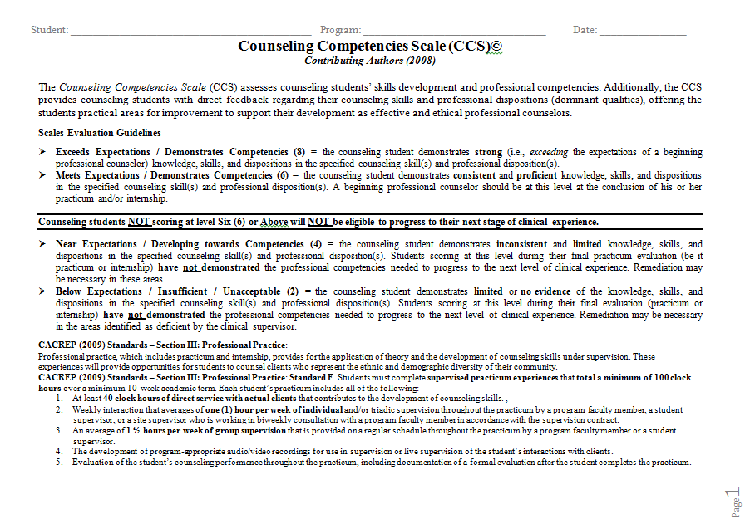

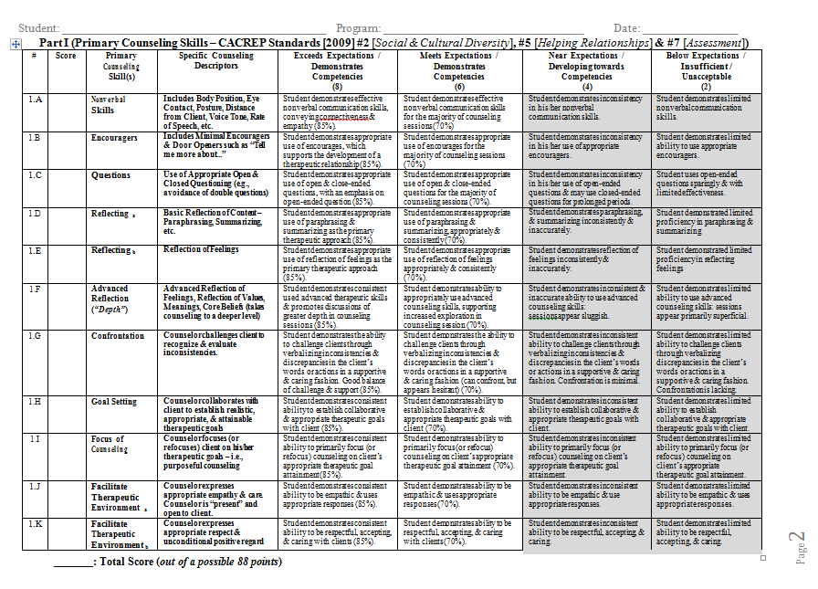

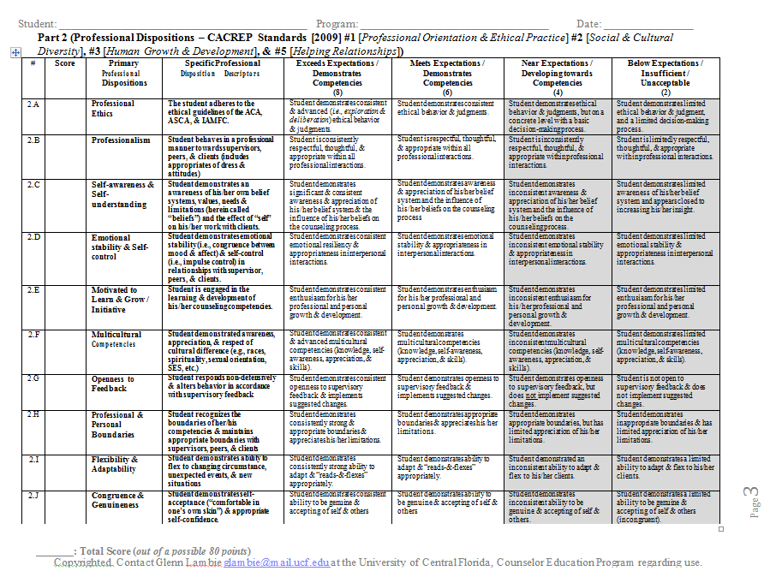

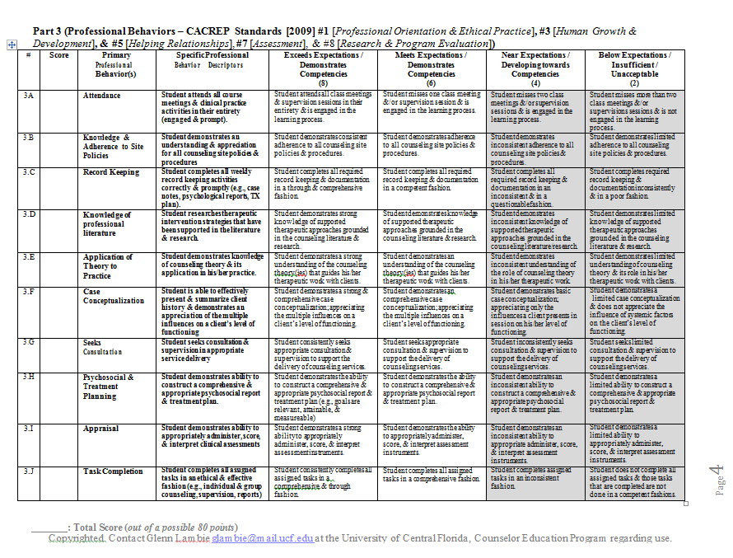

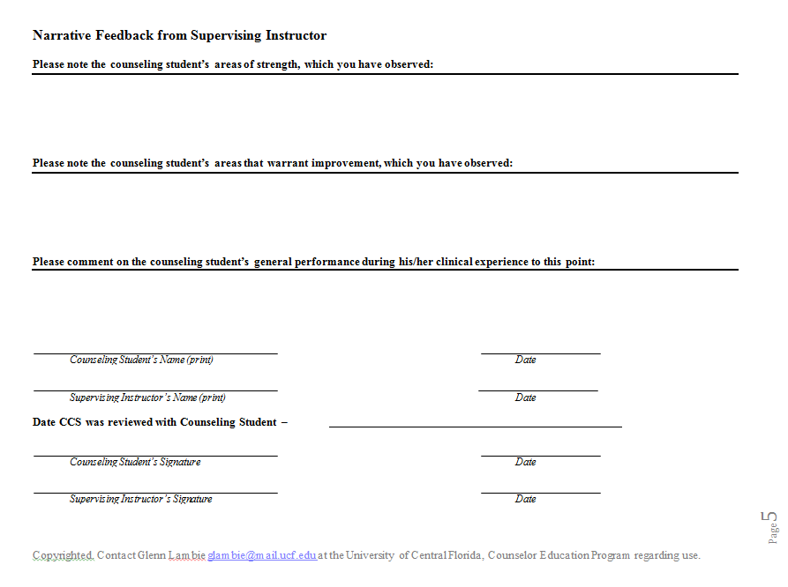

Professional School Counseling Program
2009 CORE CACREP

Students will demonstrate mastery of program objectives by successful completion of the corresponding academic coursework and process-oriented outcomes required in field placement experiences. Mastery will be accessed by coursework grades, CPCE, and field placement evaluations.

PROFESSIONAL ORIENTATION AND ETHICAL PRACTICE
a. history and philosophy of the counseling profession;
b. professional roles, functions, and relationships with other human service
providers, including strategies for inter-agency/inter-organization collaboration and communications;
c. counselors’ roles and responsibilities as members of an interdisciplinary
emergency management response team during a local, regional, or national
crisis, disaster or other trauma-causing event;
d. self-care strategies appropriate to the counselor role;
e. counseling supervision models, practices, and processes;
f. professional organizations, including membership benefits, activities, services
to members, and current issues;
g. professional credentialing, including certification, licensure, and accreditation
practices and standards, and the effects of public policy on these issues;
h. the role and process of the professional counselor advocating on behalf of the
i. profession;
j. advocacy processes needed to address institutional and social barriers that
impede access, equity, and success for clients; and
k. ethical standards of professional organizations and credentialing bodies, and
applications of ethical and legal considerations in professional counseling.

SOCIAL AND CULTURAL DIVERSITY
a. multicultural and pluralistic trends, including characteristics and concerns
within and among diverse groups nationally and internationally;
b. attitudes, beliefs, understandings, and acculturative experiences, including
specific experiential learning activities designed to foster students’
understanding of self and culturally diverse clients;
c. theories of multicultural counseling, identity development, and social justice;
d. individual, couple, family, group, and community strategies for working with
and advocating for diverse populations, including multicultural competencies;
e. counselors’ roles in developing cultural self-awareness, promoting cultural
social justice, advocacy and conflict resolution, and other culturally supported
behaviors that promote optimal wellness and growth of the human spirit,
mind, or body; and
f. counselors’ roles in eliminating biases, prejudices, and processes of
intentional and unintentional oppression and discrimination.

HUMAN GROWTH AND DEVELOPMENT
a. theories of individual and family development and transitions across the life
span;
b. theories of learning and personality development, including current
understandings about neurobiological behavior;
c. effects of crises, disasters, and other trauma-causing events on persons of all
ages;
d. theories and models of individual, cultural, couple, family, and community
resilience;
e. a general framework for understanding exceptional abilities and strategies for
differentiated interventions;
f. human behavior, including an understanding of developmental crises,
disability, psychopathology, and situational and environmental factors that
affect both normal and abnormal behavior;
g. theories and etiology of addictions and addictive behaviors, including
strategies for prevention, intervention, and treatment; and
h. theories for facilitating optimal development and wellness over the life span.

CAREER DEVELOPMENT
a. career development theories and decision-making models;
b. career, avocational, educational, occupational and labor market information
resources, and career information systems;
c. career development program planning, organization, implementation,
administration, and evaluation;
d. interrelationships among and between work, family, and other life roles and
factors, including the role of multicultural issues in career development;
e. career and educational planning, placement, follow-up, and evaluation;
f. assessment instruments and techniques relevant to career planning and
decision making; and
g. career counseling processes, techniques, and resources, including those
applicable to specific populations in a global economy.

HELPING RELATIONSHIPS
a. an orientation to wellness and prevention as desired counseling goals;
b. counselor characteristics and behaviors that influence helping processes;
c. essential interviewing and counseling skills;
d. counseling theories that provide the student with models to conceptualize
client presentation and that help the student select appropriate counseling
interventions. Students will be exposed to models of counseling that are
consistent with current professional research and practice in the field so they
begin to develop a personal model of counseling;
e. a systems perspective that provides an understanding of family and other
systems theories and major models of family and related interventions;
f. a general framework for understanding and practicing consultation; and
g. crisis intervention and suicide prevention models, including the use of
psychological first aid strategies.

GROUP WORK
a. principles of group dynamics, including group process components,
developmental stage theories, group members’ roles and behaviors, and
therapeutic factors of group work;
b. group leadership or facilitation styles and approaches, including
characteristics of various types of group leaders and leadership styles;
c. theories of group counseling, including commonalities, distinguishing
characteristics, and pertinent research and literature;
d. group counseling methods, including group counselor orientations and
behaviors, appropriate selection criteria and methods, and methods of
evaluation of effectiveness; and
e. direct experiences in which students participate as group members in a small
group activity, approved by the program, for a minimum of 10 clock hours
over the course of one academic term.

ASSESSMENT
a. historical perspectives concerning the nature and meaning of assessment;
b. basic concepts of standardized and non-standardized testing and other
assessment techniques, including norm-referenced and criterion-referenced
assessment, environmental assessment, performance assessment, individual
and group test and inventory methods, psychological testing, and behavioral
observations;
c. statistical concepts, including scales of measurement, measures of central
tendency, indices of variability, shapes and types of distributions, and
correlations;
d. reliability (i.e., theory of measurement error, models of reliability, and the use
of reliability information);
e. validity (i.e., evidence of validity, types of validity, and the relationship
between reliability and validity);
f. social and cultural factors related to the assessment and evaluation of
individuals, groups, and specific populations; and
g. ethical strategies for selecting, administering, and interpreting assessment and
evaluation instruments and techniques in counseling.

RESEARCH AND PROGRAM EVALUATION
a. the importance of research in advancing the counseling profession;
b. research methods such as qualitative, quantitative, single-case designs, action
research, and outcome-based research;
c. statistical methods used in conducting research and program evaluation;
d. principles, models, and applications of needs assessment, program evaluation,
and the use of findings to effect program modifications;
e. the use of research to inform evidence-based practice; and
f. ethical and culturally relevant strategies for interpreting and reporting the
results of research and/or program evaluation studies.

School Counseling Specialty

FOUNDATIONS

Knowledge
a. Knows history, philosophy, and trends in school counseling and educational
systems.
b. Understands ethical and legal considerations specifically related to the practice of
school counseling.
c. Knows roles, functions, settings, and professional identity of the school counselor
in relation to the roles of other professional and support personnel in the school.
d. Knows professional organizations, preparation standards, and credentials that are
relevant to the practice of school counseling.
e. Understands current models of school counseling programs (e.g., American
School Counselor Association [ASCA] National Model) and their integral
relationship to the total educational program.
f. Understands the effects of (a) atypical growth and development, (b) health and
wellness, (c) language, (d) ability level, (e) multicultural issues, and (f) factors of
resiliency on student learning and development.
g. Understands the operation of the school emergency management plan and the
roles and responsibilities of the school counselor during crises, disasters, and
other trauma-causing events

Skills and Practices
a. Demonstrates the ability to apply and adhere to ethical and legal standards in
school counseling.
b. Demonstrates the ability to articulate, model, and advocate for an appropriate
school counselor identity and program.

COUNSELING, PREVENTION, AND INTERVENTION

Knowledge
a. Knows the theories and processes of effective counseling and wellness programs
for individual students and groups of students.
b. Knows how to design, implement, manage, and evaluate programs to enhance the
academic, career, and personal/social development of students.
c. Knows strategies for helping students identify strengths and cope with
environmental and developmental problems.
d. Knows how to design, implement, manage, and evaluate transition programs,
including school-to-work, postsecondary planning, and college admissions
counseling.
e. Understands group dynamics—including counseling, psycho-educational, task,
and peer helping groups—and the facilitation of teams to enable students to
overcome barriers and impediments to learning.
f. Understands the potential impact of crises, emergencies, and disasters on students,
educators, and schools, and knows the skills needed for crisis intervention.

Skills and Practices
a. Demonstrates self-awareness, sensitivity to others, and the skills needed to relate
to diverse individuals, groups, and classrooms.
b. Provides individual and group counseling and classroom guidance to promote the
academic, career, and personal/social development of students.
c. Designs and implements prevention and intervention plans related to the effects of
a. atypical growth and development, (b) health and wellness, (c) language, (d) ability level, (e) multicultural issues, and (f) factors of resiliency on student learning and development.
d. Demonstrates the ability to use procedures for assessing and managing suicide
risk.
e. Demonstrates the ability to recognize his or her limitations as a school counselor
and to seek supervision or refer clients when appropriate.

DIVERSITY AND ADVOCACY

Knowledge
a. Understands the cultural, ethical, economic, legal, and political issues surrounding
diversity, equity, and excellence in terms of student learning.
b. Identifies community, environmental, and institutional opportunities that
enhance—as well as barriers that impede—the academic, career, and
personal/social development of students.
c. Understands the ways in which educational policies, programs, and practices can
be developed, adapted, and modified to be culturally congruent with the needs of
students and their families.
d. Understands multicultural counseling issues, as well as the impact of ability
levels, stereotyping, family, socioeconomic status, gender, and sexual identity,
and their effects on student achievement.

Skills and Practices
a. Demonstrates multicultural competencies in relation to diversity, equity, and
opportunity in student learning and development.
b. Advocates for the learning and academic experiences necessary to promote the
academic, career, and personal/social development of students.
c. Advocates for school policies, programs, and services that enhance a positive
school climate and are equitable and responsive to multicultural student
populations.
d. Engages parents, guardians, and families to promote the academic, career, and
personal/social development of students.

Assessment

Knowledge
a. Understands the influence of multiple factors (e.g., abuse, violence, eating
disorders, attention deficit hyperactivity disorder, childhood depression) that may
affect the personal, social, and academic functioning of students.
b. Knows the signs and symptoms of substance abuse in children and adolescents, as
well as the signs and symptoms of living in a home where substance abuse occurs.
c. Identifies various forms of needs assessments for academic, career, and
personal/social development.

Skills and Practices
a. Assesses and interprets students’ strengths and needs, recognizing uniqueness in
cultures, languages, values, backgrounds, and abilities.
b. Selects appropriate assessment strategies that can be used to evaluate a student’s
academic, career, and personal/social development.
c. Analyzes assessment information in a manner that produces valid inferences when
evaluating the needs of individual students and assessing the effectiveness of
educational programs.
d. Makes appropriate referrals to school and/or community resources.
e. Assesses barriers that impede students’ academic, career, and personal/social
development.

Research and Evaluation

Knowledge
a. Understands how to critically evaluate research relevant to the practice of school
counseling.
b. Knows models of program evaluation for school counseling programs.
c. Knows basic strategies for evaluating counseling outcomes in school counseling
(e.g., behavioral observation, program evaluation).
d. Knows current methods of using data to inform decision making and
accountability (e.g., school improvement plan, school report card).
e. Understands the outcome research data and best practices identified in the school
counseling research literature.

Skills and Practices
a. Applies relevant research findings to inform the practice of school counseling.
b. Develops measurable outcomes for school counseling programs, activities,
interventions, and experiences.
c. Analyzes and uses data to enhance school counseling programs.

ACADEMIC DEVELOPMENT

Knowledge
a. Understands the relationship of the school counseling program to the academic
mission of the school.
b. Understands the concepts, principles, strategies, programs, and practices designed
to close the achievement gap, promote student academic success, and prevent
students from dropping out of school.
c. Understands curriculum design, lesson plan development, classroom management
strategies, and differentiated instructional strategies for teaching counseling- and
guidance-related material.

Skills and Practices
a. Conducts programs designed to enhance student academic development.
b. Implements strategies and activities to prepare students for a full range of
postsecondary options and opportunities.
c. Implements differentiated instructional strategies that draw on subject matter and
pedagogical content knowledge and skills to promote student achievement.

COLLABORATION AND CONSULTATION

Knowledge
a. Understands the ways in which student development, well-being, and learning are
enhanced by family-school-community collaboration.
b. Knows strategies to promote, develop, and enhance effective teamwork within the
school and the larger community.
c. Knows how to build effective working teams of school staff, parents, and community members to promote the academic, career, and personal/social development of students.
d. Understands systems theories, models, and processes of consultation in school system settings.
e. Knows strategies and methods for working with parents, guardians, families, and
communities to empower them to act on behalf of their children.
f. Understands the various peer programming interventions (e.g., peer meditation,
peer mentoring, peer tutoring) and how to coordinate them.
g. Knows school and community collaboration models for crisis/disaster
preparedness and response.

Skills and Practices
a. Works with parents, guardians, and families to act on behalf of their children to
address problems that affect student success in school.
b. Locates resources in the community that can be used in the school to improve
student achievement and success.
c. Consults with teachers, staff, and community-based organizations to promote
student academic, career, and personal/social development.
d. Uses peer helping strategies in the school counseling program.
e. Uses referral procedures with helping agents in the community (e.g., mental
health centers, businesses, service groups) to secure assistance for students and
their families.

LEADERSHIP

Knowledge
a. Knows the qualities, principles, skills, and styles of effective leadership.
b. Knows strategies of leadership designed to enhance the learning environment of schools.
c. Knows how to design, implement, manage, and evaluate a comprehensive school counseling program.
d. Understands the important role of the school counselor as a system change agent.
e. Understands the school counselor’s role in student assistance programs, school leadership, curriculum, and advisory meetings.

Skills and Practices
a. Participates in the design, implementation, management, and evaluation of a comprehensive developmental school counseling program.
b. Plans and presents school-counseling-related educational programs for use with parents and teachers (e.g., parent education programs, materials used in classroom guidance and advisor/advisee programs for teachers).

~~~ PROGRAM CHECKPOINTS & TIMELINE ~~~
(all information is subject to change)
(current to 08/15)

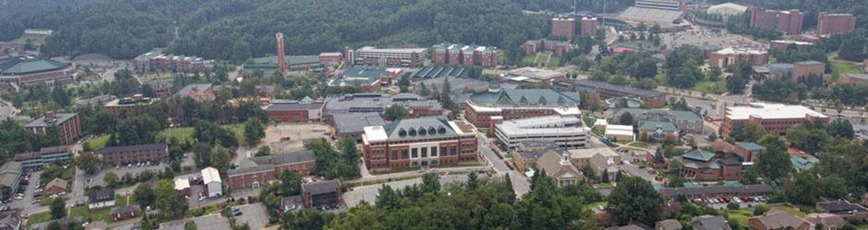

Fall Semester of Year #1
- October/November: Clarify personal career goals; outline intended courses for program of study
- Meet with your advisor to plan a potential program of study (POS) based upon your career goals
Spring Semester of Year #1
- January/February: Finalize your Program of Study (POS) and communicate the final plan to your advisor via meeting or email. (The Graduate School will not allow students to enroll for following-semester classes if they are close to exceeding the maximum credits allowable without a POS approved and on file in their office – so meet with your advisor before registration for summer and fall courses opens). The University uses the online DegreeWorks program to complete and file programs of study. Trainings are made available to students regularly during the fall and spring semesters. Look for emails from ASU regarding advising and using the DegreeWorks system. The POS planning form can help you as you think about your program of study, and is available online at: http://www.graduate.appstate.edu/gradstudies/bulletin10/policies/programofstudy.html
- IF you are planning to take Practicum in the Fall of your second year, you must obtain approval from your advisor and department chair prior to registration for Practicum. Approval forms needed to do this include: the Permission to Register form, the completed and approved-by-faculty CCS form from your Year 1 review, and others – all of which are available online or in the file box in the HPC Office. The application deadline for fall practicum is February 1; deadline for spring practicum is October 1. You must have completed core courses: 5220 (Theories), 5225 (Helping Relationship), 5310 (Intro to PSC), and 5790 (Groups) prior to beginning your practicum experience.

Summer (or semester) Prior to Practicum:
- Criminal Background Check: If you are requesting field placement in a county which has its own Criminal Background Check procedure (e.g., Watauga, Avery, etc), you will complete that county schools’ process. If you are requesting placement in a county without their own CBC process, then you will complete the ASU CBC process. The proper paperwork for either process is provided during Prac/Intern registration and/or advisement meeting. Students initiating only the ASU CBC process will turn in their forms to the PSC Field Placement Coordinator and then complete the second part of the CBC process online as per the email received from ASU/RCOE. Those completing the county schools’ processes will deal directly with the county they are requesting placement in – this process is not governed or facilitated by ASU. Note: the Appalachian State University CBC lasts only one calendar year; students requiring greater than one year to complete Practicum and Internship will be required to initiate a second background check.)

- Obtain documentation that you have taken and received a negative TB test – or that you have been screened by Student Health Services and do not need to be tested. These documents can be obtained from the local health department or student health services. TB tests also last one calendar year only; those needing longer than a calendar year to complete all their field placement hours will need to complete this process twice, as an active and negative TB test or waiver must be on file in the student’s ASU records.
Fall Semester of Second Year: (or for some, their first fall semester)
- Present at the Annual NCSCA Fall Conference. Students may choose to present a poster presentation –others a lecture-format presentation to meet this program requirement. Information is made available to students in both their Introduction to Professional School Counseling course and in the Seminar in Professional School Counseling course. Students who choose to present in their first semester of the program at the fall conference will have met the program’s presentation requirement for graduation. This is also an assignment in the Seminar course and will be graded at the time of course enrollment. NCCA presentation (or any state or national professional organization’s annual conference) is acceptable as well.

- Students Receiving Financial Aid: It is a Federal Department of Education requirement that any student taking more than 54 semester hour needs to file an appeal with the Financial Aid office (routinely approved). This application for appeal provides a necessary paper trail for the federal loan program and the student’s financial aid account. Students: be advised! Without filing this Appeal prior to completion of 54 credit hours, your student account may be in danger.

Semester During Practicum (Recommended) or During Internship:
- Register for the HPC Comps Exam: the Counselor Preparation Comprehensive Exam (CPCE). Exam dates are set for each semester and announced each fall. You must register 4-5 weeks before the exam date. There is a cost of $45 to register for the standardized CPCE. There are preparatory books you may borrow from the HPC resource library or you may choose purchase the tape series or books to assist you in studying for the exam. The department will send out emails at least 6 weeks prior to registration for the exam.

- Register for Internship: application deadlines are February 1 for fall internship and October 1 for spring internship. You must have completed the core courses prerequisite to 5900 and 5210 (Career), 5140 (Testing), 5750 (Legal/Ethical), and 6620 (Consultation) prior to beginning Internship.

- Attend the Mandatory Internship Meeting (typically scheduled for three hours the last day of the preceding-internship semester). You are required to attend a mandatory internship orientation meeting at the end of the semester prior to your enrollment in internship, and you must receive formal approval from the PSC committee for your internship site. Students not in attendance at the meeting will need to postpone their Internship experiences for liability reasons.
Internship Semester OR the Semester Prior to Graduation:
- Register for Graduation: During the course registration period when you are registering for your final semester of classes, apply online at the graduate school website for your Diploma and Graduation. If you will WALK the following semester, but NOT graduate (ie: take your last class in the summer following graduation), then register online to WALK for graduation, but do not apply to graduate. You must apply to graduate at the beginning of the semester in which all your coursework will be completed.

- Begin your job search. Register on the DPI website for the state(s) you wish to work in. The NC DPI website allows you to select those counties in which you have particular interest.

- Visit the Career Services Center on campus to register for their assistance with signing up for the twice-per-year Career Fair, assistance workshops with interviewing, resumes, and coverletters. Write your coverletters. Finalize your resume. Use them! They are an excellent resource – and as an ASU graduate, you are eligible for life-long services (FYI).

- Assemble your Professional Portfolio (begun in Intro and completed in Internship) and finalize it. Begin mining the contacts you have made during the Program (site supervisors, guest speakers, program alumni, classmates, friends/family with public school contacts, alumni contacts made at the NCSCA conferences, NCCA conferences, etc), and find out what position openings are on the horizon. Bookmark county websites that have job posting pages – and check them weekly.

- If you are requesting letters of recommendation from faculty, ask them early so they have several weeks to provide the letter or reference. Remember, you are looking for jobs at the same time faculty are winding up the semester and year, grading, working on your graduation and licensure paperwork, preparing for the incoming cohort, etc. Plan accordingly!

- NO LATER THAN THE THIRD WEEK OF THE SEMSETER: Register for and take no later than the end of March the NTE/Praxis Exam (online test code: 5421 beginning in February 2013), Counseling Specialty portion only. Request that your scores be sent to ASU.

- Apply for DPI Licensure as a School Counselor/Guidance Counselor at the Office of Field Experiences (located in the Dean’s office). Cost is $55 payable to “NCDPI”. Your Internship supervisor will remind you of the deadlines and walk you through the processes. Stay on top of this paperwork – it takes weeks to complete; you need to have all your paperwork in by early/mid-June if you want to have licensure and be able to work in the fall after your graduation.

- Take the NCE: Optional – But Recommended. As a graduate of a CACREP accredited graduate counseling program, you are eligible to sit for the National Counselor Exam (NCE). A passing score on the exam grants you eligibility to apply for the Nationally Certified Counselor (NCC) credential. It also (later) grants you the option to apply for the Nationally Certified School Counselor (NCSC) credential.

- Get a Physical: Optional – But Recommended. Obtain a Physical Exam at the Student Health Center before graduation. You will need one before working in most school systems and they are expensive if you are in the coverage gap between your master’s work and your first job in the schools. Because your ASU student fees largely cover this cost if you obtain one while enrolled as a student, you might be proactive about this.
Summer After Graduation: Stay in touch over the hiring-summer! Let the faculty help you in your job hunt.
Once Hired: Contact Dr. Graves to let her know where you have been hired. We want to share your outstanding news with our ASU PSC Community!
November after you graduate: Meet us at the NCSCA Conference and join us for the Alumni Social at the Bonefish Grill on Thursday night!!!

Appalachian State University: Professional School Counseling

Student Handbook

Understanding and Acknowledgment

Student: Complete this form and give a copy to the HPC 5310 Introduction to Professional School Counseling instructor by the designated date. This form will be placed in each PSC program student’s file and represents that you understand the standards, policies, and responsibilities established for the program. Please keep a copy for your records.

I, ________________(student name), have downloaded and read the Appalachian State University’s Professional School Counseling Program’s Student Handbook and understand that I am responsible for the information presented therein.

I understand the policies and procedures, and my responsibilities as stated in the Student Handbook. I agree to fulfill the requirements as stated and to abide by the policies set forth herein.

I further understand that faculty of Appalachian State University’s Professional School Counseling Program has the right and responsibility to monitor my academic progress, my professional behavior, my professional disposition, and my personal characteristics during my entire time in the program. Based on that monitoring, decisions will be made about my standing in the counseling program—whether I will continue without restriction, will continue with restriction and/or remediation, or termination from the program.

I understand and agree to the conditions of this handbook. Any breach of this agreement constitutes grounds for being removed from the counseling program. I also understand the Professional School Counseling program’s retention policy, and I am clear that there are certain behaviors that, if violated, will supersede this agreement including remediation services and, instead, may result in immediate removal from the program (e.g., ethics violations).

Signature Date _______

Print name

